Incident report analysis
Scenario
A multimedia company experienced a network outage caused by a denial-of-service (DoS) attack. The attack flooded the network with ICMP packets, making all services unavailable for about two hours.

The issue was traced to a misconfigured firewall that allowed excessive ICMP traffic. The security team responded by blocking ICMP traffic, shutting down non-critical systems, and restoring essential services.

You are required to analyze this incident using the NIST Cybersecurity Framework and suggest improvement

Summary | The company faced a network outage due to a DDoS attack using ICMP flood traffic. The attack overwhelmed the network, causing services to stop working. The team controlled the attack by blocking ICMP traffic and prioritizing critical systems.
Identify | - The incident was a DDoS attack using ICMP flooding.  - The attacker targeted the internal network, affecting all services.  - Critical systems were disrupted and needed to be restored quickly
Protect | - The team added firewall rules to limit ICMP traffic.  - They also implemented IDS/IPS to filter suspicious packets.  - These steps help reduce the risk of similar attacks in the future
Detect | - The team enabled monitoring tools to detect unusual traffic.  - Firewall checks were added to identify spoofed IP addresses. This helps detect abnormal activity earlier.
Respond | - During the attack, the team blocked malicious traffic and stopped non-critical services.  - For future incidents, they will isolate affected systems and analyze logs to understand the attack. Incidents will also be reported to management.
Recover | - Critical systems were restored first to bring the network back online.  - Once the attack traffic reduced, other services were restarted.  - Future recovery plans include faster detection and better traffic control.

Figure 1: ICMP Flood Traffic
Shows large volume of ICMP packets indicating a DDoS attack.
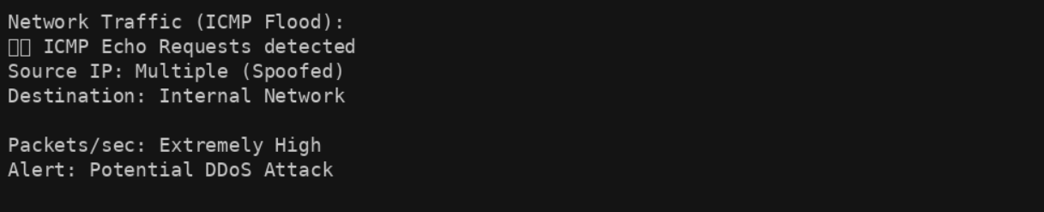

Figure 2: Firewall Rule to Limit ICMP Traffic
Displays security control used to mitigate the attack.
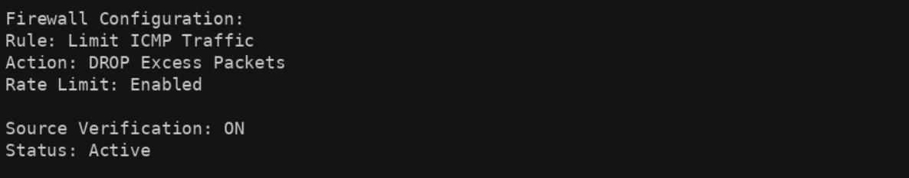

Figure 3: DDoS Attack Flow
Illustrates how attackers flooded the network causing service disruption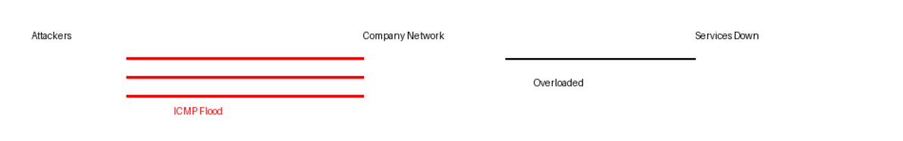
For each NIST function, I have added the security impact to show not just what actions were taken, but why they matter from a business perspective.

Summary Security Impact
The attack caused a complete network outage, affecting business operations and service availability.
- Identify
Security Impact: Critical network services were disrupted, leading to loss of access to internal resources.
- Protect
Security Impact: Improved controls reduce the likelihood of similar attacks and strengthen overall network security.
- Detect
Security Impact: Faster detection of abnormal traffic helps minimize downtime and limits attack impact.
- Respond
Security Impact: Effective response actions help contain the attack quickly and prevent further damage.
- Recover
Security Impact: Structured recovery ensures critical systems are restored quickly, reducing business disruption.

